6.Design and Configuration of Tree Topologies using Packet Tracer.

Tree Topology using Hub:

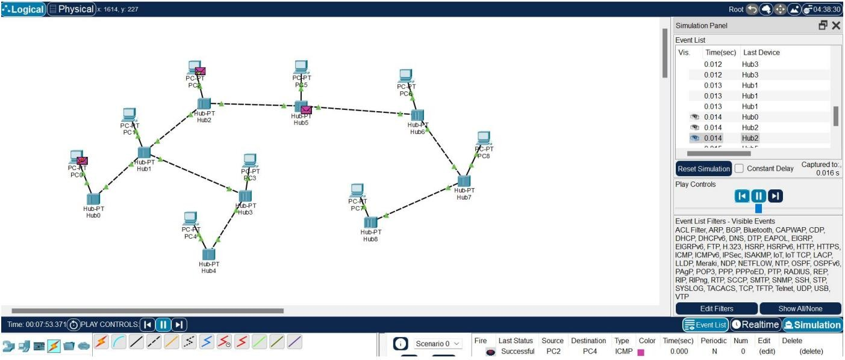

Tree Topology using Switch:

